**Model Development Phase Template**

|  |  |
| --- | --- |
| Date | 06 JUNE 2024 |
| Team ID | SWTID1720260935 |
| Project Title | Ecommerce Shipping Prediction Using Machine Learning |
| Maximum Marks | 4 Marks |

**Initial Model Training Code, Model Validation and Evaluation Report:**

The initial model training code will be showcased in the future through a screenshot. The model validation and evaluation report will include classification reports, accuracy, and confusion matrices for multiple models, presented through respective screenshots.

**Initial Model Training Code:**

**Supportvectormachine**

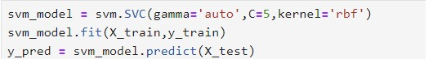

Randomforestclassifier

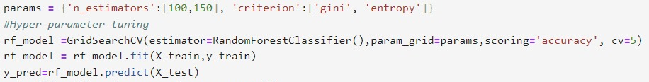

Aritificialneutalnetwork

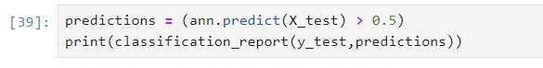

Logisticregression:

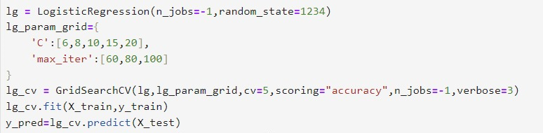

XG BOOST CLASSIFIER:

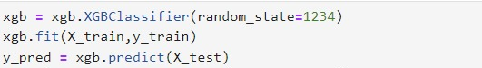

K- Nearest neighbours classifier:

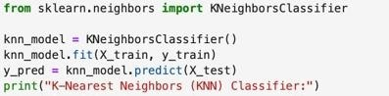

**Model Validation and Evaluation Report:**

|  |  |  |  |
| --- | --- | --- | --- |
| **Model** | **Classification Report** | **Accuracy** | **Confusion Matrix** |
| Support Vector Machine |  | 66% |  |
| Artificial Neutral Network |  | 67% |  |
| Logistic Regression |  | 64% |  |
| Random Forest Classifirer |  | 66% |  |
| XGBoost Classifier |  | 66% |  |
| KNN Neighbours Classifier |  | 65% |  |